Java Script Assignment

**1. Find the smallest number in an array**

Create a function that will display the smallest value in the array.

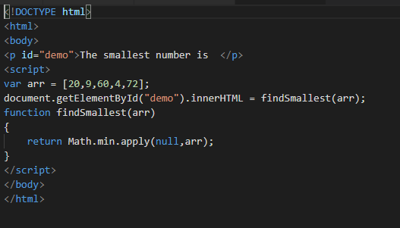

2. Sort strings by Alphabetical Order

Function that will return your string in Alphabetical order

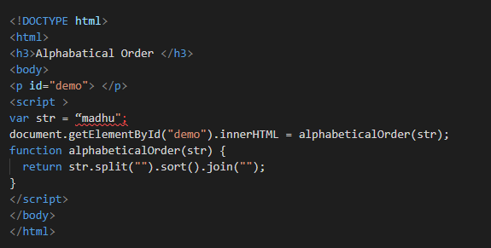

**3. Factorialize a number**

In mathematics, the factorial of a non-negative integer n, denoted by n!, is the product of all positive integers less than or equal to n. In simple terms, the Factorial of 7 is solved like this:

**7 _ 6 _ 5 _ 4 _ 3 _ 2 _ 1 = 5,040**

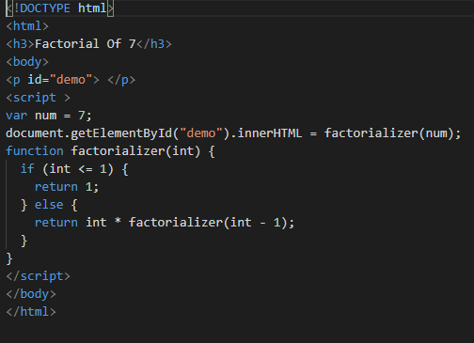

**4. Identify if a number is Odd or Even?**

A function that lets you know if a number is Even or Odd

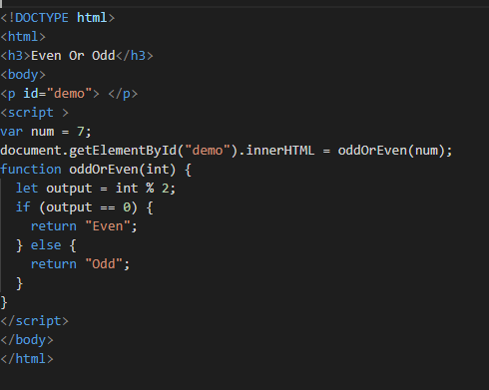

**5. Eliminate all odd numbers in an array.**

Remove all Odd number(s) in an array and return a new array that contains Even numbers only

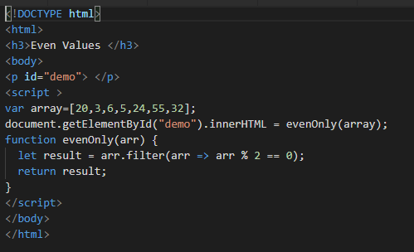

**6. Return numbers only**

Create a function that will accept an array, check the data type of each element. The function will delete string elements and will return a the new array

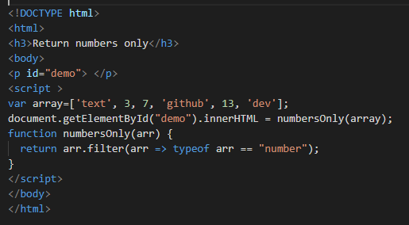

**7. Add up the numbers**

Return the sum of a number going back to it's root. In other words, the function will work like this:

**addUp(5);**

// 5 + 4 + 3 + 2 + 1 + 0 = **15**

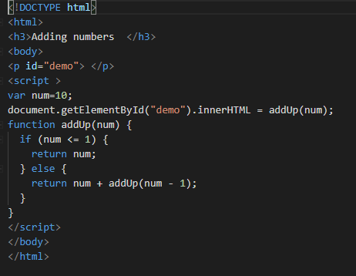

**8. Return the Min, Max, Length and Average of an Array**

Create a function that will accept an array and do the following:

* Get the lowest element
* Get the highest element
* Get the length of array
* Get the Average of all element;
* Store these criteria in a new array

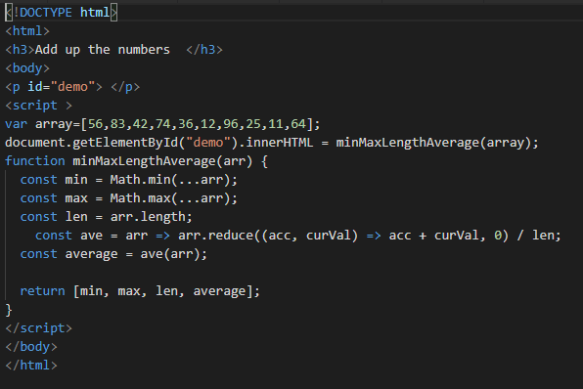

**9. Sort Numbers in Ascending Order**

Array.sort() sorts the **strings** alphabetically. What if we want to sort **numbers** from lowest to highest? Will it produce a correct output?

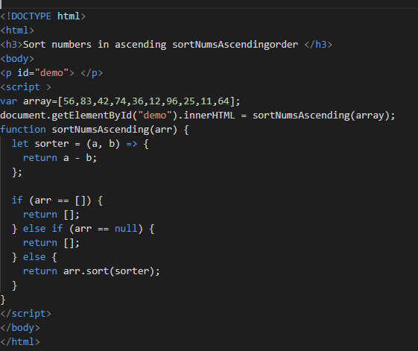

**10. Convert Numbers in Roman Numerals**

Convert the given number to a Roman Numeral

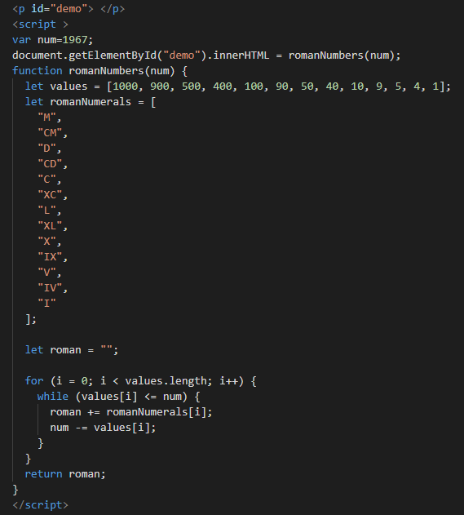

**11.Absolute Sum**

Return the absolute sum of all the array elements

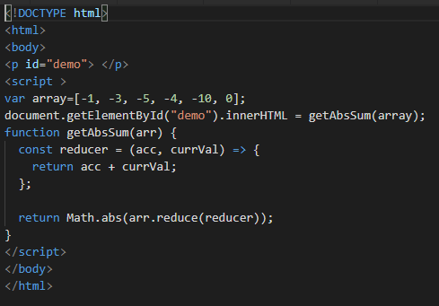

**12.Lopping a triangle**

Form a triangle using hash tags

**Example:**

> #

> ##

> ###

> ####

> #####

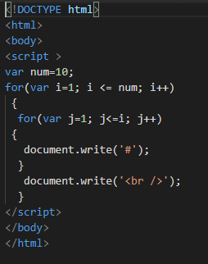

**13.Count the number of words**

Return how many words was given

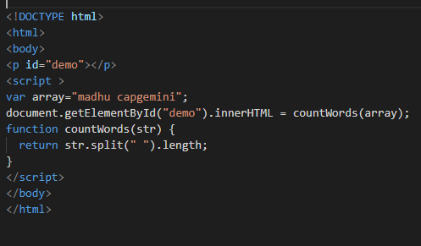

**14.Multiply by length**

Multiply all elements in an array by it's length

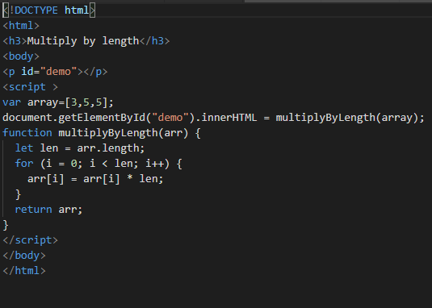

**15. Repeating letters**

Create a function that will repeat each string character two times

